**Functions Practice Problems**

1. Help user find degF or degC based on their Conversion Selection. Use Case Statement and ensure that the inputs are within the Freezing Point ( 0 °C / 32 °F ) and the Boiling Point of Water ( 100 °C / 212 °F )

a. degF = (degC * 9/5) + 32 b. degC = (degF – 32) * 5/9

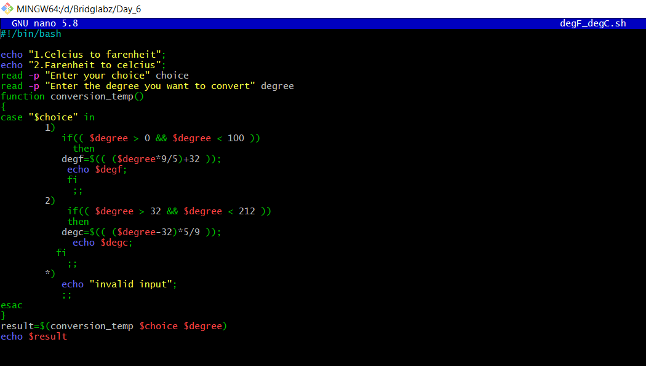

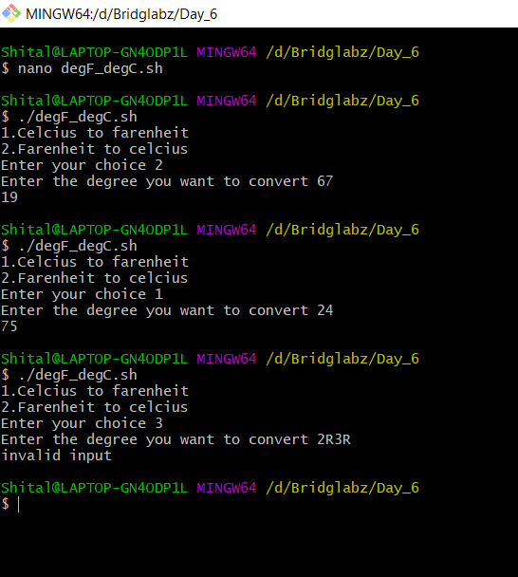

2. Write a function to check if the two numbers are Palindromes

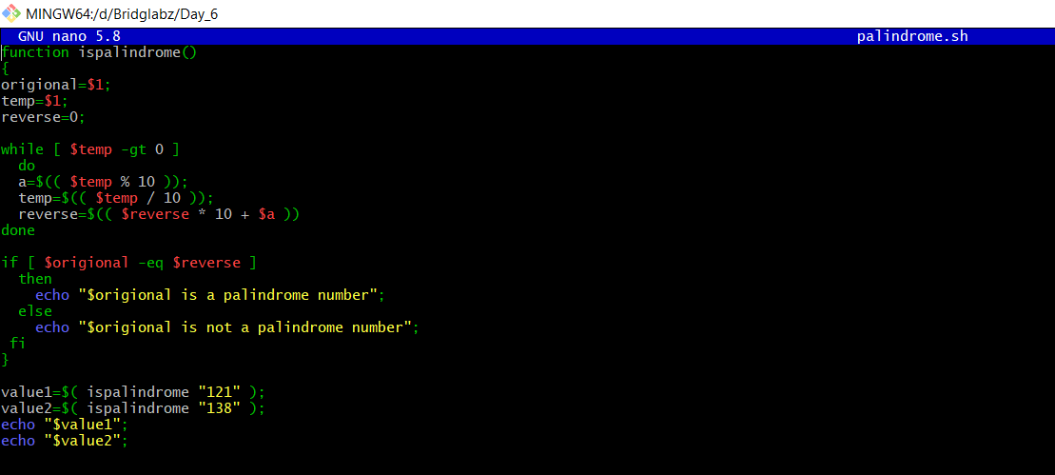

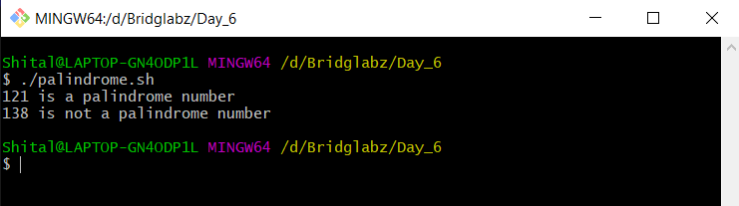

3. Take a number from user and check if the number is a Prime then show that its palindrome is also prime

a. Write function check if number is Prime

b. Write function to get the Palindrome

c. Check if the Palindrome number is also prime

